1. The distance between two cities is input through the keyboard . Write a program to convert and print this in meters, feet and inches.

Hint: 1km=1000 m

1m=3.2 feet

1feet=12 inches

#include<iostream>

#include<conio.h>

using namespace std;

int main()

{

float km; // a variable defined for user input in kilometers

float inches; //variable for inches

float feet; //variable for feet

float meters; //variable for meters

cout << "Enter your distance kilometers: "; // output statement

cin >> km;

meters = 1000 * km;

feet = meters * 3.2;

inches = feet * 12;

cout << "Distance in meters is " << meters << endl;

cout << "Distance in feet is " << feet << endl;

cout << "Distance in inches is " << inches;

getch();

return 0;

}

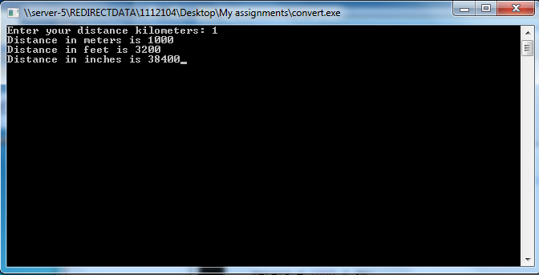

5.if mass of an object is to be input from keyboard , write a program to find Force exerted by an objected if it is falling from height on earth. Define acceleration due to gravity as constant variable.

Hint: F=m*g

#include<iostream>

#include<conio.h>

using namespace std;

int main()

{

float f;

const float g = 9.8;

int m;

cout << "Enter mass: ";

cin >> m;

f = m * g;

cout << "F = " << f;

getch();

return 0;

}

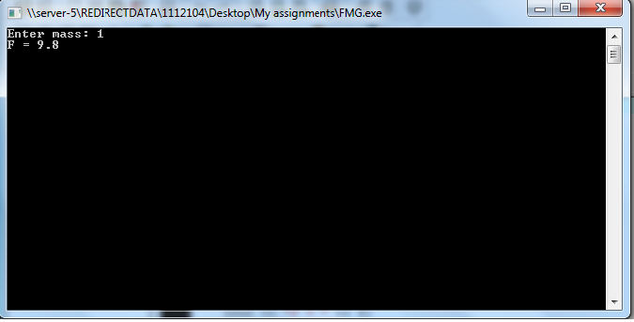

2. the length & breath of a rectangle and Area of Circle are to be input through keyboard. Define value of “PI” to be Literal Constant before main program. Find area of rectangle, Parameter of rectangle Circumference of Circle and area of Circle .

Hint: area of rectangle=breath*length

Parameter of rectangle=2(length +breath)

Area of circle =PI r*2

Circumference of Circle=2*PI*r

#include<iostream>

#include<conio.h>

using namespace std;

int main()

{

float length;

float breath;

float radius;

float area_of_rect;

float peri_of_rect;

float area_of_cric;

float circum_of_cric;

const float PI = 3.1415;

cout << "Enter length: ";

cin >> length;

cout << "Enter breath: ";

cin >> breath;

cout << "Enter radius";

cin >> radius;

area_of_rect = length * breath;

peri_of_rect = 2*(length + breath);

area_of_cric = PI * radius * radius;

circum_of_cric = 2 * PI * radius;

cout << "Area of rectangle: " << area_of_rect;

cout << "Perimeter of rectangle: " << peri_of_rect;

cout << "Area of Circle: " << area_of_cric;

cout << "Circumference of Circle: " << circum_of_cric;

getch();

return 0;

}

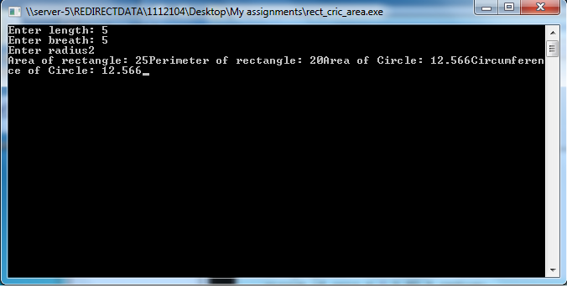

6.two numbers are to be input from the keyboard into two integer variables . Write a program to interchange their value.

#include<iostream>

#include<conio.h>

using namespace std;

int main()

{

int a = 4;

int b = 5;

cout << "Value for a " << a << endl;

cout << "Value for b " << b << endl;

int temp = a;

a = b;

b = temp;

cout << "Now value of a is " << a << endl;

cout << "Now value of b is " << b;

getch();

return 0;

}

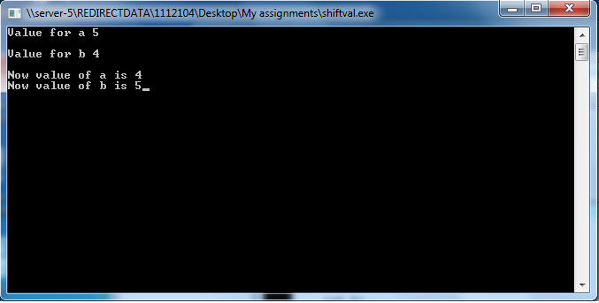

4.If total Selling Price, Total No: of Items and total %age of profit earned on them is to be input from keyboard.Write a program to find the total cost price and cost price of 1 item.

Hint: CostPrice=Selling Price-Profit

#include<iostream>

#include<conio.h>

using namespace std;

int main()

{

int sp;

int totl_num_itm;

int per;

float cp;

float c_of_1itm;

cout << "Enter selling price(space)total number of items(space)profit percentage: ";

cin >> sp >> totl_num_itm >> per;

cp = sp-(sp*per/100);

cout << "Cost price of " << totl_num_itm <<" is "<< cp << endl;

c_of_1itm = cp/totl_num_itm;

cout << "Cost of 1 item is " << c_of_1itm;

getch();

return 0;

}

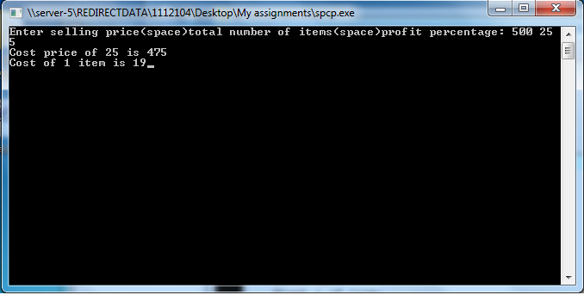

3.Cost of a wooden pencil is 0.3 RS . Aslam had amount of 30 RS , write a program to find number of pencil Aslam can buy with this amount.

#include<iostream>

#include<conio.h>

using namespace std;

int main()

{

cout << "3.Cost of a wooden pencil is 0.3 RS ."<<

endl << "Aslam had amount of 30 RS ,"<<

endl <<"write a program to find number of pencil"<<

endl <<"Aslam can buy with this amount. " << endl;

cout << "Cost of a wooden pencil = 0.3" << endl;

cout << "Aslam had a amount of RS.30" << endl;

const float p = 0.3;

const int amont = 30;

cout << "Aslam can buy " << amont/p << " pencils.";

getch();

return 0;

}

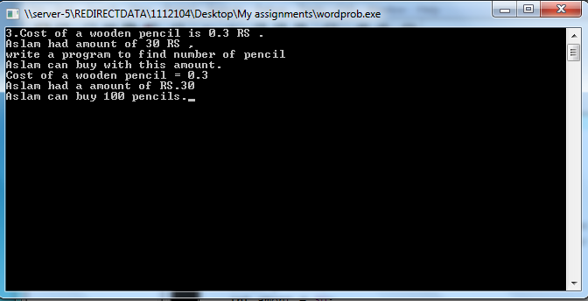

#include<iostream>

#include<conio.h>

using namespace std;

int main()

{

float time, rate, principle, interest;

cout << "Enter principle(space)rate(space)time:";

cin >> principle >> rate >>time;

interest = principle * rate/100 * time;

cout << "Interest is " << interest << " per anum.";

getch();

return 0;

}

